 | Technical Report - Python  Google Data Analyst Specialist  CLS ONL2_DAT1_G2 |  | 
Sponsorship
Ministry of Communications and Information Technology
(MCIT) Egypt

Digital Egypt Pioneers Initiative
DEPI

Project Idea 6: (Outstanding)
UK Train Rides.

Supervised by
Dr. Yasser A. Rahman
Prepared by: Elite Team
Ahmed Hussein Ali Mustafa
Fatma Alzahraa Galal Abd-elsalam Soliman
Heba Tallah Talaat Ezzat Ibrahim
Kareman Mohamed Mahmoud Awad

Data preparation:
Importing libraries & data frame.
import pandas as pd

from google.colab import drive

print(df.isnull().sum())

Operation analysis:
- Purchase Channel Distribution: Count of purchases made online vs. at stations.
Purchase_type | Count
Station | 13132
Online | 18521

purchase_type = df['purchase_type'].value_counts()
print("Purchase Type Distribution:\n", purchase_type)

- Payment Method Distribution: Breakdown of purchases by credit card, contactless, etc.
Most used payment_method

payment_method | Revenue
Debit Card | 52966
Credit Card | 469511
Contactless | 219444

revenue_by_method = df.groupby('payment_method')['price'].sum()
print("Revenue by Payment Method:\n", revenue_by_method)

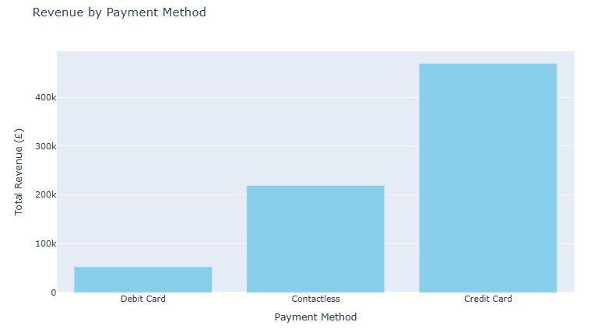
revenue_by_method = df.groupby('payment_method')['price'].sum()
print("Revenue by Payment Method:\n", revenue_by_method)
total_revenue = df['price'].sum()
print("Total Revenue:", total_revenue)
total_refunds = df[df['refund_request'] == "Yes"]['price'].sum()

- Railcard Usage Rate: Count of transactions that used a railcard.

Railcard | Count
Adult | 4846
Senior | 2800
Disabled | 3089
None | 20922

rail_card_usage = df['rail_card'].value_counts()
print("Rail Card Usage:\n", rail_card_usage)

- Percentage of transactions that used a railcard not none .

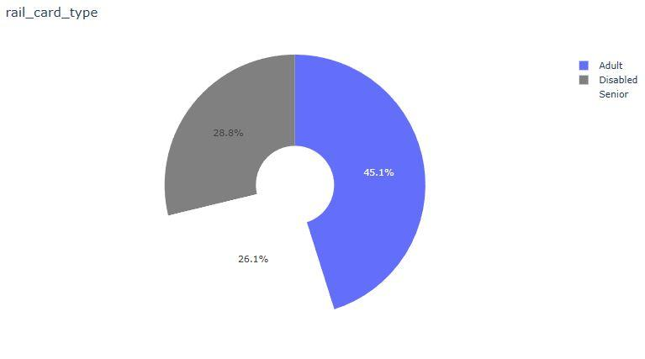

labels_2 = ['Adult', 'Disabled', 'Senior']
values_2 = [rail_card_usage['Adult'], rail_card_usage['Disabled'], rail_card_usage['Senior']]
colors = ['baby_blue', 'gray', 'white']
fig = go.Figure(data=[go.Pie(labels=labels_2, values=values_2, hole=.3, marker_colors=colors)])
fig.update_layout(title='rail_card_type')
fig.show()

- Ticket class: Breakdown of purchases by ticket class.

ticket_class | count | percentage
Standard | 28595 | 90.34
First Class | 3058 | 9.66

ticket_sales_by_class = df.groupby('ticket_class')['transaction_id'].count()
print("Ticket Sales by Class:\n", ticket_sales_by_class)

Ticket Type: Breakdown of purchases by ticket type.

ticket_type | percentage
Off-Peak | 27.65
Anytime | 16.87
Advance | 55.48

ticket_type_dist = df['ticket_type'].value_counts(normalize=True) * 100
print("Ticket Type Distribution (%):\n", ticket_type_dist)

- Top Departure Station:

departure_station | count
Manchester Piccadilly | 5650
London Euston | 4954
Liverpool Lime Street | 4561
London Paddington | 4500
London Kings Cross | 4229

top_departure = df['departure_station'].value_counts().head(5)
print("Top Departure Stations:\n", top_departure)

- Top Arrival Destination:
arrival_destination | count
Birmingham New Street | 7742
Liverpool Lime Street | 5022
York | 4019
Manchester Piccadilly | 3968
Reading | 3920

top_arrival = df['arrival_destination'].value_counts().head(5)
print("Top Arrival Stations:\n", top_arrival)

Journey status:

journey_status | count
On Time | 27481
Delayed | 2292
Cancelled | 1880
Total Journeys | 31653

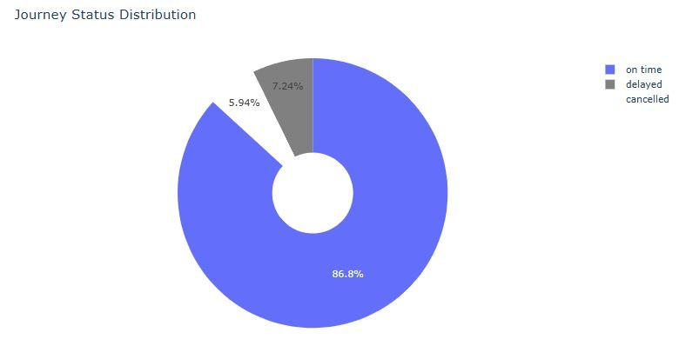
total_journeys = df['transaction_id'].count()
on_time_journeys = df[df['journey_status'] == 'On Time']['transaction_id'].count()
delayed_journeys = df[df['journey_status'] == 'Delayed']['transaction_id'].count()
cancelled_journeys = df[df['journey_status'] == 'Cancelled']['transaction_id'].count()
print("Total Journeys:", total_journeys)
print("On Time Journeys:", on_time_journeys)
print("Delayed Journeys:", delayed_journeys)
print("Cancelled Journeys:", cancelled_journeys)
Most Delayed & Cancelled Routes: Routes with the highest number of delays.

departure_station | arrival_destination | count_of_delay
Liverpool Lime Street | London Euston | 879
Manchester Piccadilly | Liverpool Lime Street | 644
London Euston | Birmingham New Street | 453
London Paddington | Reading | 352
London Kings Cross | York | 329

delayed_routes = df[df['journey_status'] != 'On Time'].groupby('route').size().sort_values(ascending=False).head(5)
print("Most Frequently Delayed & Cancelled Routes:\n", delayed_routes)
Analysis of Delay Causes and Refund Requests:

Delay Reason | Count of delay
Weather Conditions | 1372
Signal Failures | 970
Staffing | 809
Technical Issues | 707
Traffic | 314

weather_conditions = df[df['delay_reason']=="Weather Conditions"]['transaction_id'].count()
signal_failures = df[df['delay_reason']=="Signal Failure"]['transaction_id'].count()
staffing = df[df['delay_reason']=="Staffing"]['transaction_id'].count()
technical_issues = df[df['delay_reason']=="Technical Issue"]['transaction_id'].count()
traffic = df[df['delay_reason']=="Traffic"]['transaction_id'].count()
print("Weather Conditions:\n", weather_conditions)
print("Signal Failures:\n", signal_failures)
print("Staffing:\n", staffing)
print("Technical Issues:\n", technical_issues)
print("Traffic:\n", traffic)
Revenue Metrics:
Total Revenue: 741921
Total Refunds: 38702
Net Revenue: 703219

total_revenue = df['price'].sum()
print("Total Revenue:", total_revenue)
total_refunds = df[df['refund_request'] == "Yes"]['price'].sum()
print("Total Refunds:", total_refunds)
net_revenue = total_revenue - total_refunds
print("Net Revenue:", net_revenue)

- Average Ticket Price by Purchase Hour
purchase_hour_am_pm | Price
01 AM | 17.66
01 PM | 20.18
02 AM | 25.91
02 PM | 17.69
03 AM | 23.10
03 PM | 32.81
04 AM | 22.94
04 PM | 19.03
05 AM | 27.10
05 PM | 18.66
06 AM | 57.96
06 PM | 22.67
07 AM | 23.85
07 PM | 10.51
08 AM | 18.05
08 PM | 17.7
09 AM | 33.22
09 PM | 17.09
09 AM | 15.95
10 PM | 10.13
10 AM | 18.58
11 PM | 20.44
12 AM | 22.92
12 PM | 17.73

df['purchase_hour_am_pm'] = pd.to_datetime(df['purchase_time'].astype(str)).dt.strftime('%I %p')
price_by_hour_am_pm = df.groupby('purchase_hour_am_pm')['price'].mean().sort_index()
print("Average Ticket Price by Purchase Hour (AM/PM):\n", price_by_hour_am_pm)

- Peak vs Off-Peak Stats
Peak vs Off-Peak Stats:
time_period ticket_sales total_revenue
Evening Peak 8302 171631
Morning Peak 8086 279559
Off-Peak 15265 290731

def get_time_period(hour):
if 6 <= hour <= 8:
return 'Morning Peak'
elif 16 <= hour <= 18:
return 'Evening Peak'
else:
return 'Off-Peak'
df['departure_hour'] = pd.to_datetime(df['departure_time'].astype(str)).dt.hour
df['time_period'] = df['departure_hour'].apply(get_time_period)
peak_stats = df.groupby('time_period').agg(
ticket_sales=('transaction_id', 'count'),
total_revenue=('price', 'sum')
)
print("Peak vs Off-Peak Stats:\n", peak_stats)

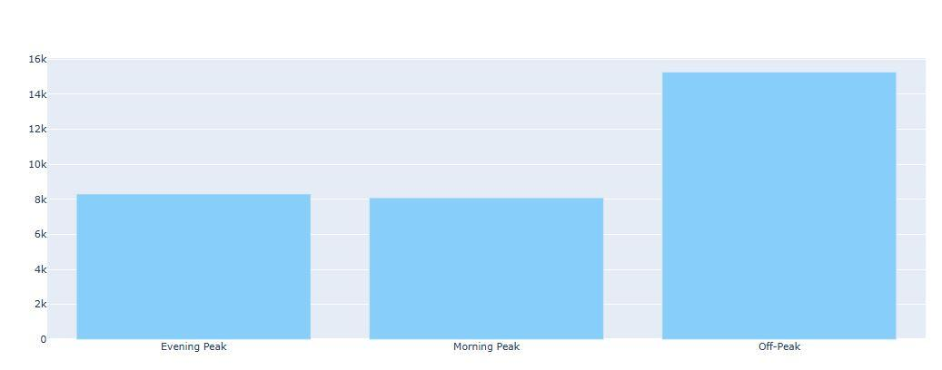

import plotly.graph_objects as go
fig = go.Figure()
fig.add_trace(go.Bar(
x=peak_stats.index,
y=peak_stats['ticket_sales'],
name='Ticket Sales',
marker_color='lightskyblue',
y axis='y'
))

- Monthly sales:
Month | Revenue
1 | 199618
2 | 159374
3 | 195147
4 | 187782

import matplotlib.pyplot as plt
import matplotlib.ticker as ticker
plt.bar(monthly_revenue.index, monthly_revenue.values, color='#dda0dd')
plt.title('Monthly Revenue')
plt.xlabel('Month')
plt.ylabel('Total Revenue (£)')
fig.show()
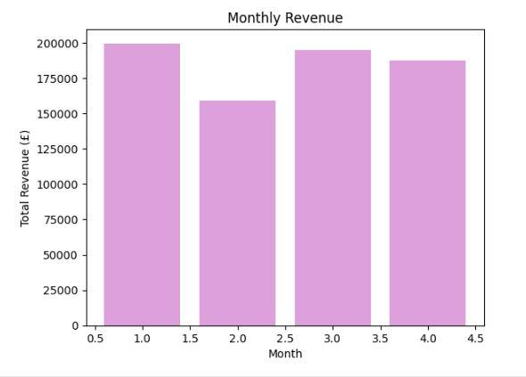
import plotly.graph_objects as go
fig = go.Figure()
fig.add_trace(go.Bar(
x=peak_stats.index,
y=peak_stats['ticket_sales'],
name='Ticket Sales',
marker_color='lightskyblue',
y axis='y'
))

- Weekly Sales :
Weekly analysis shows that weeks 19/2/2024 and 26/2/2024 have very low sales
Week | Revenue
2024-01-01 | 37941
2024-01-08 | 46752
2024-01-15 | 45069
2024-01-22 | 47584
2024-01-29 | 47579
2024-02-05 | 38811
2024-02-12 | 40280
2024-02-19 | 34762
2024-02-26 | 32543
2024-03-04 | 47299
2024-03-11 | 45403
2024-03-18 | 44599
2024-03-25 | 45517
2024-04-01 | 36415
2024-04-08 | 46914
2024-04-15 | 47050
2024-04-22 | 45760
2024-04-29 | 11643

df['week']= df['journey_date'].dt.to_period('w').apply(lambda r: r.start_time.strftime('%Y-%m-%d'))
weekly_revenue = df.groupby('week')['price'].sum()
print("Weekly Revenue:\n", weekly_revenue)

- To be more accurate
2/27/2024 2/28/2024 2/29/2024 had the least sales
According to web search that may be because of Seasonal Demand Fluctuations:
Late February typically experiences lower travel demand, as it falls between the post-holiday lull and the onset of spring, when travel usually picks up.
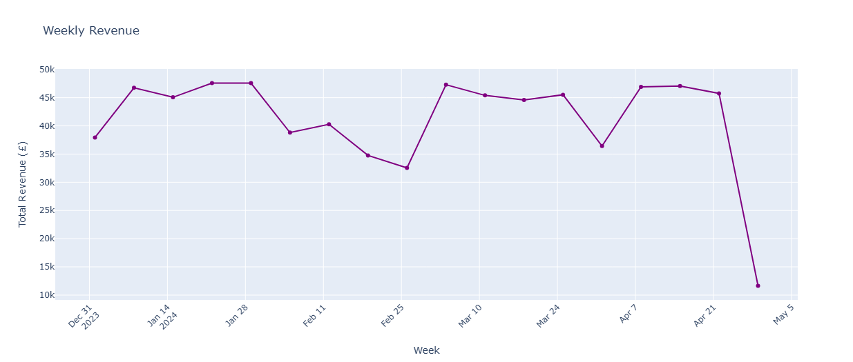
weekly_revenue = weekly_revenue.reset_index()
weekly_revenue['week'] = pd.to_datetime(weekly_revenue['week'])
weekly_revenue.rename(columns={'price': 'weekly_sales'}, inplace=True)
fig = go.Figure()
fig.add_trace(
go.Scatter(
x=weekly_revenue['week'],
y=weekly_revenue['weekly_sales'],
mode='lines+markers',
name='Weekly Revenue',
marker=dict(color='purple')
))
fig.update_layout(
title='Weekly Revenue',
xaxis_title='Week',
yaxis_title='Total Revenue (£)',
xaxis=dict(tickangle=-45)
)
fig.show()

Routes Analysis:
- Count of trips vs count of passengers for Routes.
Routes | NO. Trips | No. Passengers
Birmingham New Street → Coventry | 1 | 65
Birmingham New Street → Edinburgh Waverley | 1 | 16
Birmingham New Street → Liverpool Lime Street | 11 | 175
Birmingham New Street → London Euston | 7 | 125
Birmingham New Street → London Kings Cross | 1 | 17
Birmingham New Street → London Paddington | 2 | 32
Birmingham New Street → London St Pancras | 11 | 702
Birmingham New Street → Manchester Piccadilly | 2 | 224
Birmingham New Street → Nuneaton | 2 | 219
Birmingham New Street → Reading | 3 | 47
Birmingham New Street → Stafford | 3 | 190
Birmingham New Street → Tamworth | 2 | 227
Birmingham New Street → Wolverhampton | 1 | 32
Birmingham New Street → York | 1 | 65
Bristol Temple Meads → Cardiff Central | 1 | 16
Edinburgh Waverley → London Kings Cross | 1 | 51
Liverpool Lime Street → Birmingham New Street | 1 | 14
Liverpool Lime Street → Crewe | 3 | 193
Liverpool Lime Street → Leeds | 5 | 96
Liverpool Lime Street → London Euston | 11 | 1097
Liverpool Lime Street → London Paddington | 2 | 27
Liverpool Lime Street → London St Pancras | 2 | 31
Liverpool Lime Street → Manchester Piccadilly | 69 | 3002
Liverpool Lime Street → Sheffield | 3 | 101
London Euston → Birmingham New Street | 62 | 4209
London Euston → Manchester Piccadilly | 16 | 712
London Euston → Oxford | 1 | 16
London Euston → York | 1 | 17
London Kings Cross → Edinburgh Waverley | 1 | 163
London Kings Cross → Liverpool Lime Street | 7 | 144
London Kings Cross → York | 60 | 3922
London Paddington → Liverpool Lime Street | 3 | 44
London Paddington → London Waterloo | 1 | 68
London Paddington → Manchester Piccadilly | 2 | 30
London Paddington → Oxford | 1 | 485
London Paddington → Reading | 60 | 3873
London St Pancras → Birmingham New Street | 61 | 3471
London St Pancras → Leicester | 2 | 337
London St Pancras → Wolverhampton | 2 | 83
Manchester Piccadilly → Leeds | 5 | 142
Manchester Piccadilly → Liverpool Lime Street | 64 | 4628
Manchester Piccadilly → London Euston | 12 | 345
Manchester Piccadilly → London Kings Cross | 1 | 16
Manchester Piccadilly → London Paddington | 6 | 144
Manchester Piccadilly → London St Pancras | 1 | 16
Manchester Piccadilly → Nottingham | 2 | 158
Manchester Piccadilly → Sheffield | 10 | 171
Manchester Piccadilly → Warrington | 1 | 15
Manchester Piccadilly → York | 1 | 15
Oxford → Bristol Temple Meads | 8 | 144
Reading → Birmingham New Street | 2 | 32
Reading → Didcot | 2 | 48
Reading → Liverpool Lime Street | 1 | 16
Reading → London Paddington | 6 | 148
Reading → Oxford | 4 | 122
Reading → Swindon | 2 | 228
York → Birmingham New Street | 1 | 16
York → Doncaster | 2 | 211
York → Durham | 4 | 258
York → Edinburgh Waverley | 8 | 153
York → Leeds | 1 | 17
York → Liverpool Lime Street | 1 | 15
York → Peterborough | 4 | 242
York → Wakefield | 1 | 15

pd.set_option('display.max_rows',None)
route_summary = df.groupby('route').agg(
trips=('departure_time', 'nunique'),
passengers=('transaction_id', 'count')
).reset_index()
print(route_summary)

Insights & Conclusions:
1. Significant Variation in Passenger Numbers Across Stations:
Major stations such as Liverpool Lime Street, London Paddington, London Euston, and London Kings Cross record the highest passenger volumes, ranging from 3,800 to 5,600 passengers.
In contrast, stations like York, Oxford, and Reading have significantly lower footfall, with 500 to 900 passengers over the same period.
2. Morning Peak Hours Identified Between 6 AM and 7 AM
Several low-demand stations (e.g., Oxford, Reading, York) operate services during peak hours despite low ridership.
At the same time, critical hubs like London Kings Cross experience frequent delays due to technical issues, which puts strain on the system during rush hours.
3. Afternoon Disruptions and Underutilization
The Liverpool to London Paddington route consistently suffers from staff shortages between 3 PM and 4 PM, impacting reliability.
Meanwhile, services like York to Birmingham New Street operate with as few as 16 passengers, indicating poor resource utilization.

Recommendations
1. Reschedule or Consolidate Low-Demand Services
Reduce or merge services from low-traffic stations such as Oxford, Reading, and York during peak hours.
Reallocate resources to reinforce congested routes like London Kings Cross, especially between 6–7 AM.
2. Address Chronic Delays on Key Routes
Investigate and resolve technical issues affecting the London Kings Cross line to reduce frequent delays.
Prioritize maintenance and assign technical teams proactively to high-risk routes.

3. Improve Workforce Allocation
Reevaluate staffing plans on routes like Liverpool to London Paddington, particularly during the afternoon window (3–4 PM).
Ensure reserve staff are available during critical times to prevent shortages and delays.
4. Optimize Low-Utilization Routes
Consider canceling, merging, or rerouting services like York to Birmingham New Street with consistently low passenger counts.
Analyze long-term viability and cost-effectiveness of underperforming routes.
Forecasting:
- Journey status for the next 4 months:
Ontime Journeys:
2024-05-01 14058
2024-06-01 13286
2024-07-01 13843
2024-08-01 13377
Delayed Journeys:
2024-05-01 1080
2024-06-01 1100
2024-07-01 1227
2024-08-01 1046
Cancelled Journeys:
2024-05-01 80
2024-06-01 274
2024-07-01 22
2024-08-01 313
df['purchase_date'] = pd.to_datetime(df['purchase_date'], errors='coerce')
df['month'] = df['purchase_date'].dt.to_period('M')
status_counts = df.groupby(['month', 'journey_status']).size().unstack().fillna(0)
status_counts.index = status_counts.index.to_timestamp()
from statsmodels.tsa.arima.model import ARIMA
delayed_model = ARIMA(status_counts['Delayed'], order=(5, 1, 0))
delayed_model_fit = delayed_model.fit()
delayed_forecast = delayed_model_fit.forecast(steps=4)
print("Delayed Forecast (Next 4 Months):")
print(delayed_forecast)
on_time_model = ARIMA(status_counts['On Time'], order=(5, 1, 0))
on_time_model_fit = on_time_model.fit()
on_time_forecast = on_time_model_fit.forecast(steps=4)
print("\nOn Time Forecast (Next 4 Months):")
print(on_time_forecast)
cancelled_model = ARIMA(status_counts['Cancelled'], order=(5, 1, 0))
cancelled_model_fit = cancelled_model.fit()
cancelled_forecast = cancelled_model_fit.forecast(steps=4)
print("\nCancelled Forecast (Next 4 Months):")
print(cancelled_forecast)
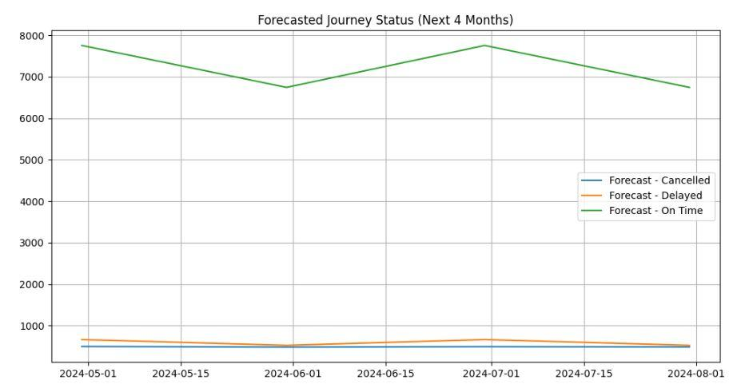
plt.figure(figsize=(12, 6))
for status in forecast_results:
plt.plot(pd.date_range(start=sales_monthly.index[-1] + pd.Timedelta(days=1), periods=4, freq='M'), forecast_results[status], label=f'Forecast - {status}')
plt.title('Forecasted Journey Status (Next 4 Months)')
plt.legend()
plt.grid()
plt.show()
- Monthly Sales for the next 4 months:
2024-05-01 196374
2024-06-01 191169
2024-07-01 194322
2024-08-01 192412
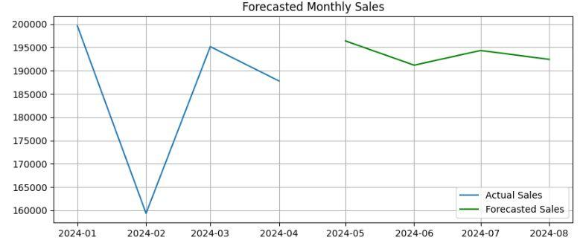
import pandas as pd
from statsmodels.tsa.arima.model import ARIMA
import matplotlib.pyplot as plt
df['journey_date'] = pd.to_datetime(df['journey_date'])
sales_monthly = df.groupby(df['journey_date'].dt.to_period('M'))['price'].sum().to_timestamp()
model = ARIMA(sales_monthly, order=(1, 1, 1))
model_fit = model.fit()
forecast_sales = model_fit.forecast(steps=4)
print("Next 4 Months Sales:")
print(forecast_sales)
plt.figure(figsize=(10, 4))
plt.plot(sales_monthly, label='Actual Sales')
plt.plot(forecast_sales, label='Forecasted Sales', color='green')
plt.title('Forecasted Monthly Sales')
plt.legend()
plt.grid()
plt.show()

What If :-
What if the revenue increased to 20% ?
Current Revenue: 741921
Target Revenue: 890305
Revenue Gain to Achieve Target: 148384
total_current_revenue=total_revenue
target_revenue = total_current_revenue * 1.20
revenue_gain = target_revenue - total_current_revenue
print("Current Revenue:", total_current_revenue)
print("Target Revenue:", target_revenue)
print("Revenue Gain to Achieve Target:", revenue_gain)

We need to determine Routes Occupancy Rate & how many trips need to be added to cover the increase in revenue.
Average Revenue per Trip: 1197
Current Number of Trips: 576
Required Trips to Achieve Target Revenue: 744
Additional Trips Needed: 168
route_summary['passengers_per_trip'] = route_summary['passengers'] / route_summary['trips']
current_number_of_trips=route_summary['trips'].sum()
avg_ticket_price=df['price'].mean()
average_ticket_price = avg_ticket_price
revenue_per_trip = route_summary['passengers_per_trip'] * average_ticket_price
average_revenue_per_trip = revenue_per_trip.mean()
print("Average Revenue per Trip:", average_revenue_per_trip)
required_trips = target_revenue / average_revenue_per_trip
additional_trips_needed = required_trips - current_number_of_trips
print("Current Number of Trips:", current_number_of_trips)
print("Required Trips to Achieve Target Revenue:", required_trips)
print("Additional Trips Needed:", additional_trips_needed)

Through our analysis, we know that the number of passengers per trip ranges from approximately 17 to 70, except for a few trip.so it was necessary to determine the number of low efficient trips

Total Trips on Low Efficiency Routes: 39
Total Passengers on Low Efficiency Routes: 604
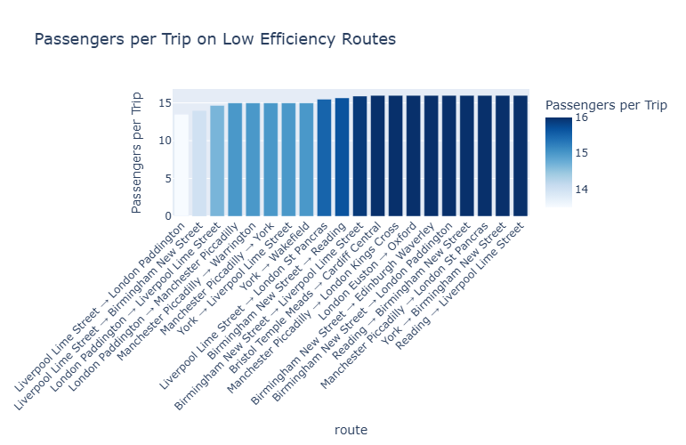

low_efficiency_routes = route_summary[route_summary['passengers_per_trip'] < 17]
total_low_trips = low_efficiency_routes['trips'].sum()
total_low_passengers = low_efficiency_routes['passengers'].sum()
print("Total Trips on Low Efficiency Routes:", total_low_trips)
print("Total Passengers on Low Efficiency Routes:", total_low_passengers)

If we study the number of less efficient trips during peak times, it will be easier for us to cancel the less efficient times and choose the busy times to avoid peak times, improve service, and provide the required trips to cover the increased revenue.

Number of Low Efficiency Trips in Peak Hours: 262

df['departure_hour'] = df['departure_time'].apply(lambda x: x.hour)
def get_time_period(hour):
if 6 <= hour <= 8:
return 'Morning Peak'
elif 16 <= hour <= 18:
return 'Evening Peak'
else:
return 'Off-Peak'
df['time_period'] = df['departure_hour'].apply(get_time_period)
low_efficiency_routes = route_summary[route_summary['passengers_per_trip'] < 17]
low_efficiency_trips = df[df['route'].isin(low_efficiency_routes['route'])]
low_efficiency_in_peak = low_efficiency_trips[
low_efficiency_trips['time_period'].isin(['Morning Peak', 'Evening Peak'])]
low_efficiency_in_peak_count = low_efficiency_in_peak.shape[0]
print("Number of Low Efficiency Trips in Peak Hours:", low_efficiency_in_peak_count)

This filtering revealed the number of low-efficiency peak-time trips that could be removed or rescheduled without heavily impacting service.
- Evaluating Route Efficiency Based on Revenue per Trip
To optimally reassign resources, we analyzed route performance using the following steps:
- Calculated the average number of passengers per trip for each route.
- Multiplied this by the average ticket price to estimate revenue per trip.
- Sorted the routes in descending order of revenue per trip to determine the most efficient ones.
avg_ticket_price = df['price'].mean()
route_summary['passengers_per_trip'] = route_summary['passengers'] / route_summary['trips']
route_summary['revenue_per_trip'] = route_summary['passengers_per_trip'] * avg_ticket_price
sorted_routes = route_summary.sort_values(by='revenue_per_trip', ascending=False)
sorted_routes['cumulative_trips'] = sorted_routes['trips'].cumsum()
top_routes = sorted_routes.head(10)
print(top_routes[['route', 'revenue_per_trip', 'trips']])

route revenue_per_trip trips
London Paddington → Oxford 11368 1
London St Pancras → Leicester 3949 2
London Kings Cross → Edinburgh Waverley 3820 1
Reading → Swindon 2672 2
Birmingham New Street → Tamworth 2660 2
Birmingham New Street → Manchester Piccadilly 2625 2
Birmingham New Street → Nuneaton 2566 2
York → Doncaster 2472 2
Liverpool Lime Street → London Euston 2337 11
Manchester Piccadilly → Nottingham 1851 2

The top-performing route generated approximately £11,368 per trip, while others ranged between £1,800 and £3,900. For instance, a route generating £2,337 per trip already operates 10 trips, indicating strong potential for expansion.

Recommendations:
- To cover the 168 additional trips needed for the revenue target, a redistribution strategy was developed
- Start by eliminating low-efficiency trips during peak time.
- Reallocate these slots to the top-performing routes based on revenue efficiency.
- Prioritize routes with proven high passenger volume and ticket revenue per trip.
This strategic redistribution ensures:
Better resource utilization
Higher probability of meeting the revenue target
Improved service quality by minimizing underused trips

